Community Learning Disability Team

Occupational Therapy


What can clients expect from our service?



We help people take part in everyday activities.


We work with people to help them take part in daily activities that are important to them.


This can be in different environments including home, college, work and in the community.


We are practical.


All visits are person centred. This means we work with you to decide on goals and make a plan for your care.


Our care focuses on problem solving, making adaptations, overcoming barriers and positive risk taking.


We are passionate about promoting people’s participation, independence and quality of life.

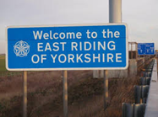


We have Teams in Hull and East Riding.



What things can we help you with?



We can help you be more independent. We can help you:


Make friends

Do activities

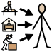
Get a job


Look after yourself

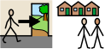
Access the community


Be safe


Offer assessment to support your postural needs



Manage your emotions


Assess and support your sensory needs

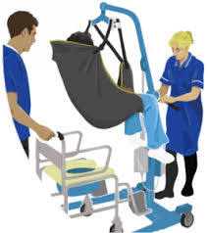
Meet your moving and handling needs


Review your environment


Choose the right equipment



Move from child to adult services




What things can’t we help you with?


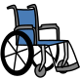
We do not provide wheelchairs. These are provided by AJM Healthcare Hull and East Riding Wheelchair Services
TEL: 0808 175 3969;
email: ajm.ery-hullwheelchairservices@nhs.net


We do not control Disabled Facilities Grants and major home adaptations.



Please contact your local social services occupational therapists:
Hull: 01482 300300
East Riding : 01482 393939.



How often will we be in contact?


We will work with you within your environment.



We will with you for a short time or a long time – depending on your needs.




Frequently asked questions


My wheelchair is broken and needs reviewing, who do I contact?


Any questions in relation to wheelchairs, please contact, AJM Healthcare Hull and East Riding Wheelchair Services
TEL: 0808 175 3969;
email: ajm.ery-hullwheelchairservices@nhs.net


My equipment is broken and needs mending, who do I contact?



If your equipment was provide by NRS and has an NRS sticker on it, please contact NRS on 0344 8936375 and tell them that it is broken. NRS will send a member of staff out to see if they are able to fix the problem. If they are not able to fix the problem, they may send you out a replacement piece of equipment or they may ask an occupational therapist to complete a re-assessment.


My equipment no longer meets my needs, who do I contact?


If your equipment no longer meets your needs, please contact CTLD Occupational therapy on 01377 208800 to discuss your change in needs with a member of the team.


When do I need to contact social service occupational therapist?

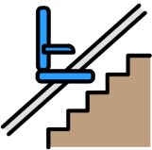
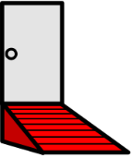

The social service occupational therapist complete assessments for major adaptations to your home such as ramps, wet rooms and stairlifts.

Please contact 01482 300 300 to make a referral.


Do you provide assistive technology?

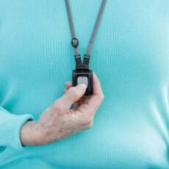
Assistive technology such as lifeline and sensors are assessed by Telecare team.

If you have any questions please contact 01482 318 700. Telecare | Hull, Aids and adaptations – Live Well Hull



Useful documents


Occupational Therapy Leaflet.
This is available on our webite page.



Other useful websites

AJM Healthcare Hull and East Riding Wheelchair Services Home - Hull and East Riding Wheelchair Service


Remap:

Remap’s mission is to design and custom- make equipment to help people with disabilities live more independently - Disability Equipment & Aids for Independent Living at Home | REMAP


The Humber Sensory Processing Hub-
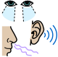
The Humber Sensory Processing Service is a specialist service providing support to children who have sensory processing difficulties. There are a number of useful resources within the website for adults and those you support them Downloads – Sensory Processing (humber.nhs.uk)


Barnsley Assistive Technology Service:
aims to improve the independence of individuals living with disabilities through the provision of electronic assistive technologies. Barnsley AT Team - Assistive Technology Team (barnsleyhospital.nhs.uk)



The local offer website is a way to make it easier for you to find out about services and support available to children and young people from birth to 25 years with special educational needs and disabilities (SEND).
Home (eastridinglocaloffer.org.uk)
Home | Hull SEND Local Offer (mylocaloffer.org)



The Live Well is a one-stop information, advice and support website for adults of all ages, abilities and backgrounds.
Live Well Hull – Live Well Hull
Community Builders (eastridinghealthandwellbeing.co.uk)



Community Navigators work with individuals to improve their health, wellbeing and social networks. Based in community settings across Hull, the team provide one-to-one, face-to-face support.
Do you need support accessing help? – Live Well Hull



The changing places website has a toilet map which shows you where you can find registered changing places toilets in Hull and East Riding of Yorkshire.
Changing Places Toilets (changing-places.org)



The aim of Euan's Guide is to empower disabled people by providing information that will give confidence and choices for getting out and about. People with a disability review environments in your local area to help prepare people for visits in the community.
Euan's Guide - Disabled Access Reviews (euansguide.com)


The CHCP website has support and advice for carers, which includes parents carers of a children with additional needs.
City Health Care Partnership (chcpcic.org.uk)


RED and friendly faces host music events in Hull for people with a learning disability
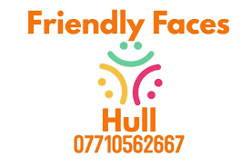
Friendly Faces Hull | New Walton Club, Walton St, Hull, UK


Hull Red - Music & Partying for Adults with Learning Disabilities

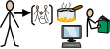
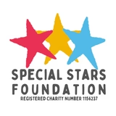
The special stars foundation focus on providing a diverse calendar of creative learning and social activities to improve the quality of life for people with significant learning and physical disabilities and their families across Hull and East Yorkshire. They also offer a range of support, training and advice services for parent carers.
Special Stars Foundation | Specialist Stockist, Inclusive Activities, Sensory Room (heyspecialstars.co.uk)

